Marking Classified Correspondence

Classified and special handling correspondence
a. General. Information that requires protection against unauthorized disclosure in the interest of national security shall be classified. The contents of a classified communication will be revealed only to individuals who have the appropriate security clearance and whose official duties require such information.

This chapter, contains illustrations and sample classified memorandums to show proper security classification marking of correspondence. The text in the illustrations (figs 1 through 3) covers most of the important information. This chapter does not:
a. Contain or reveal classified information. Markings are for illustration only.
b. Illustrate every conceivable situation that may be encountered in the production of classified correspondence.

This chapter is especially important to anyone who writes, signs, or otherwise prepares classified correspondence. Make sure that all security markings are correct.
This chapter does not provide guidance on downgrading, reclassification instructions, or additional special markings; nor does it contain illustrations on classifying original material.
Normally, the classification marking will be the largest print on the page. Consider that the classification marking on the figures are of proper size (even if they are not in some cases due to space limitations).

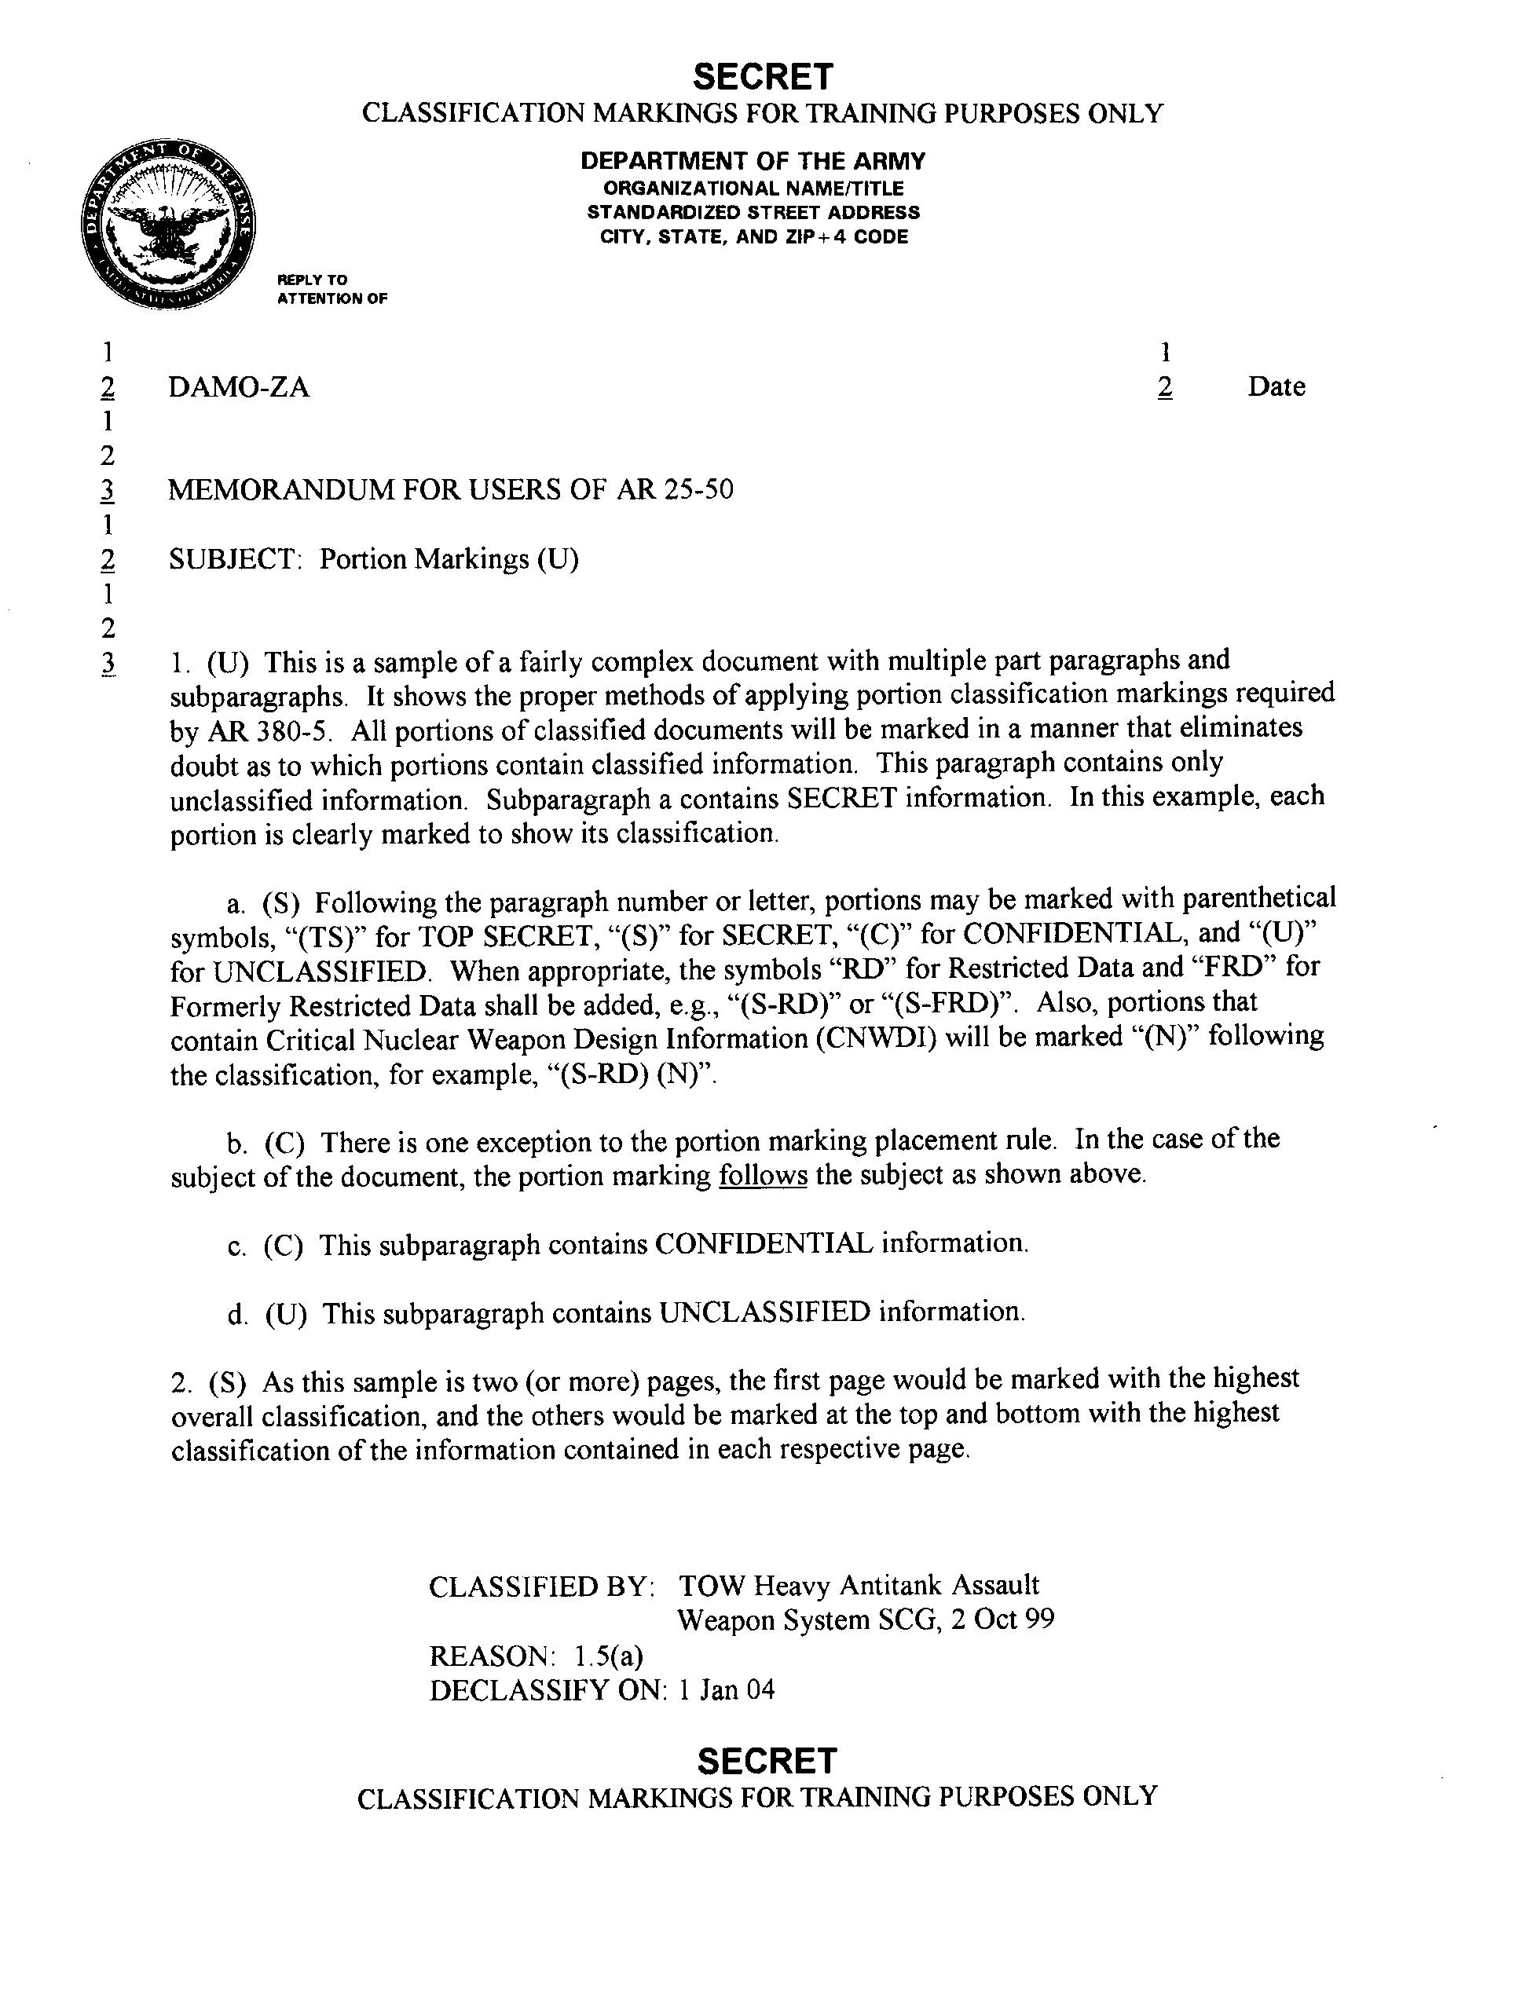
Figure 1. Marking the security classification of portions

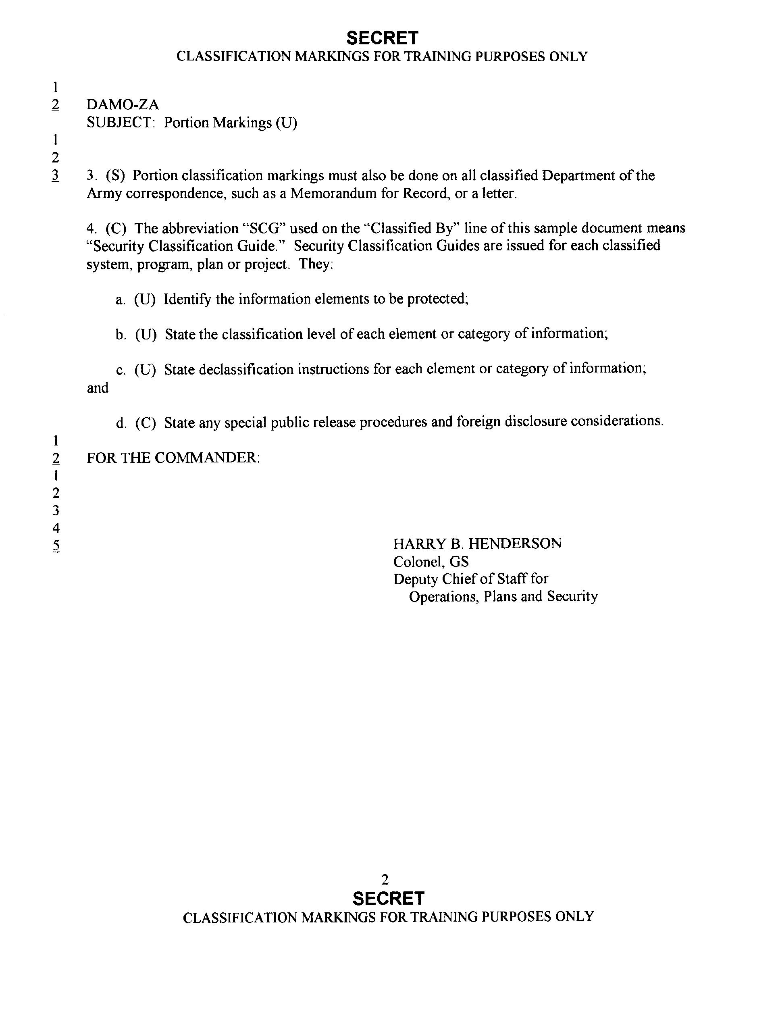
Figure 2. Marking the security classification of portions for continued pages

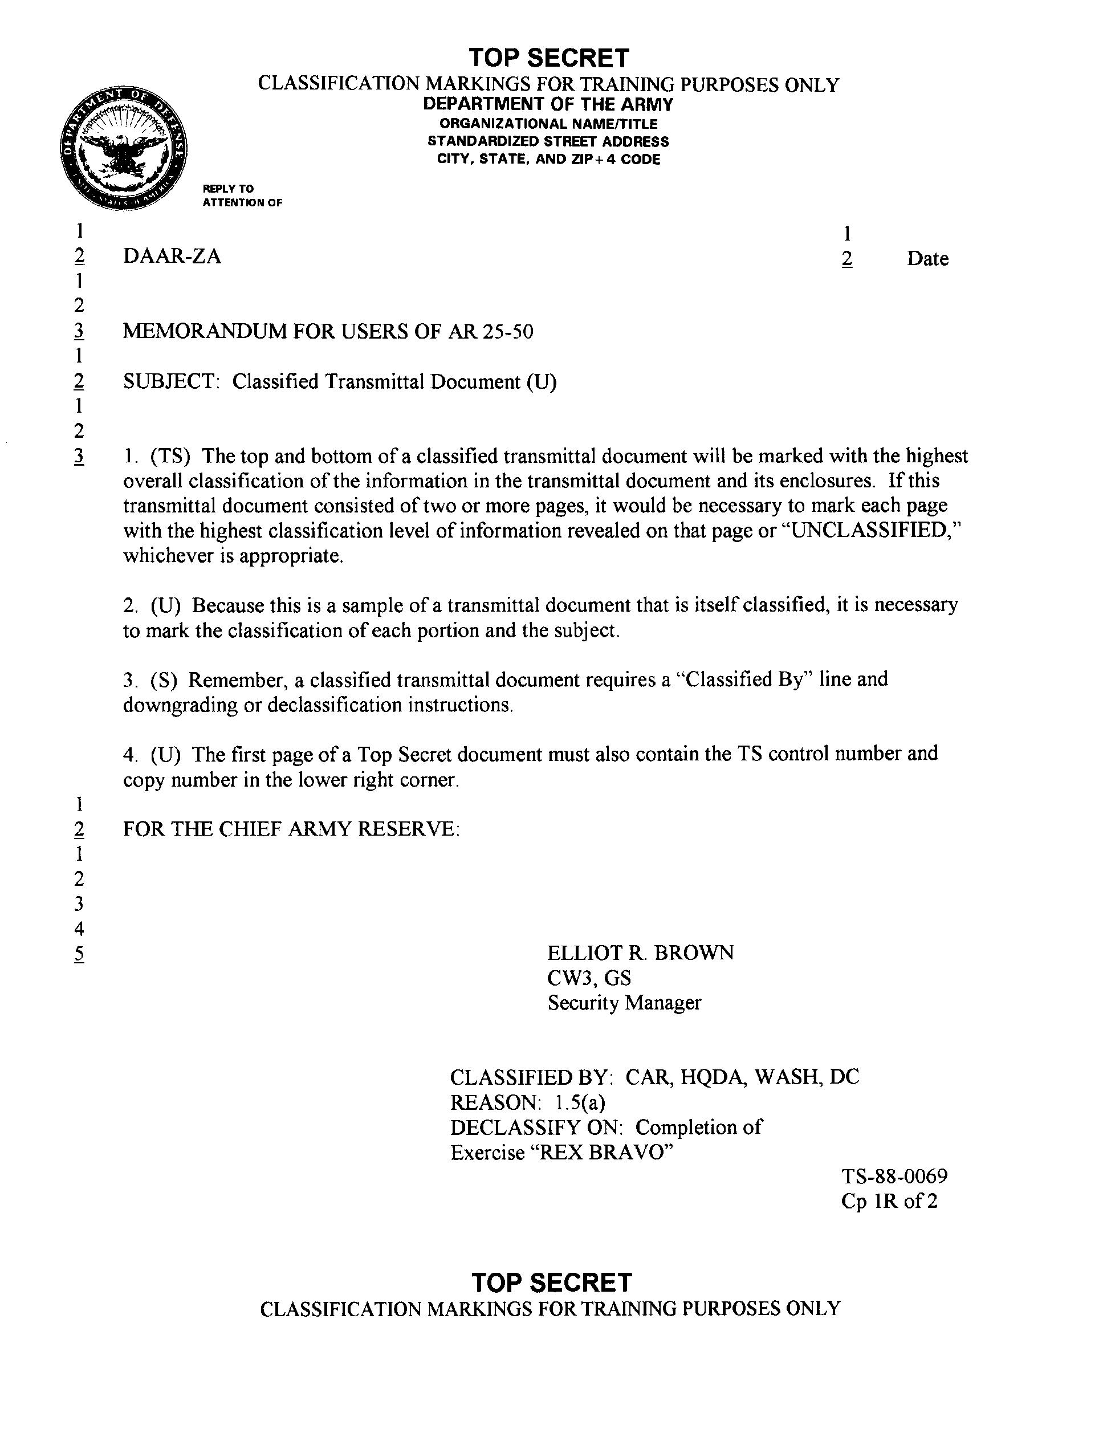
Figure 3 Classified transmittal documents

